WHAT’S YOUR NAME?
Complete the conversations.
 |  |  | 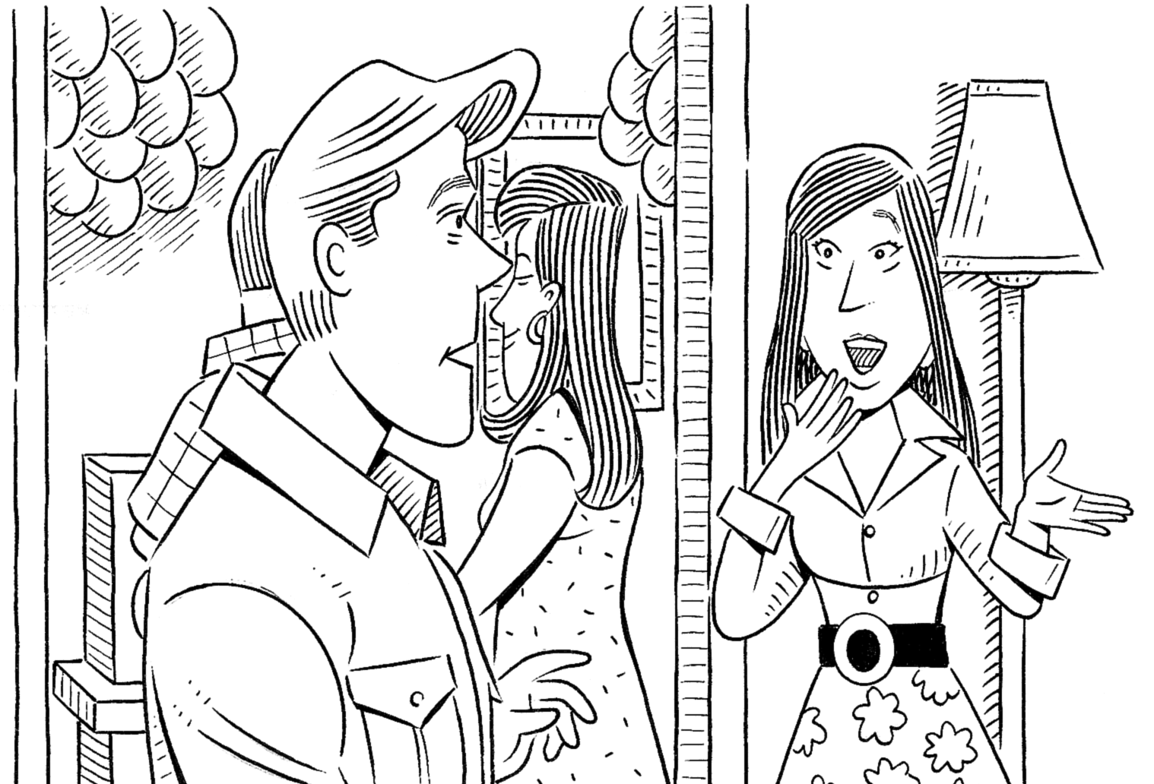
1. | Lisa: | Hi! Are you Phil?
 | Will: | Phil? I’m not Phil. My name is Will.
 | Lisa: | Oh, I’m sorry! _________ you Will Morris?
 | Will: | Yes, I _________. And what’s _________ name?
 | Lisa: | _________ Lisa Field.
2. | Will: | What’s his name? | 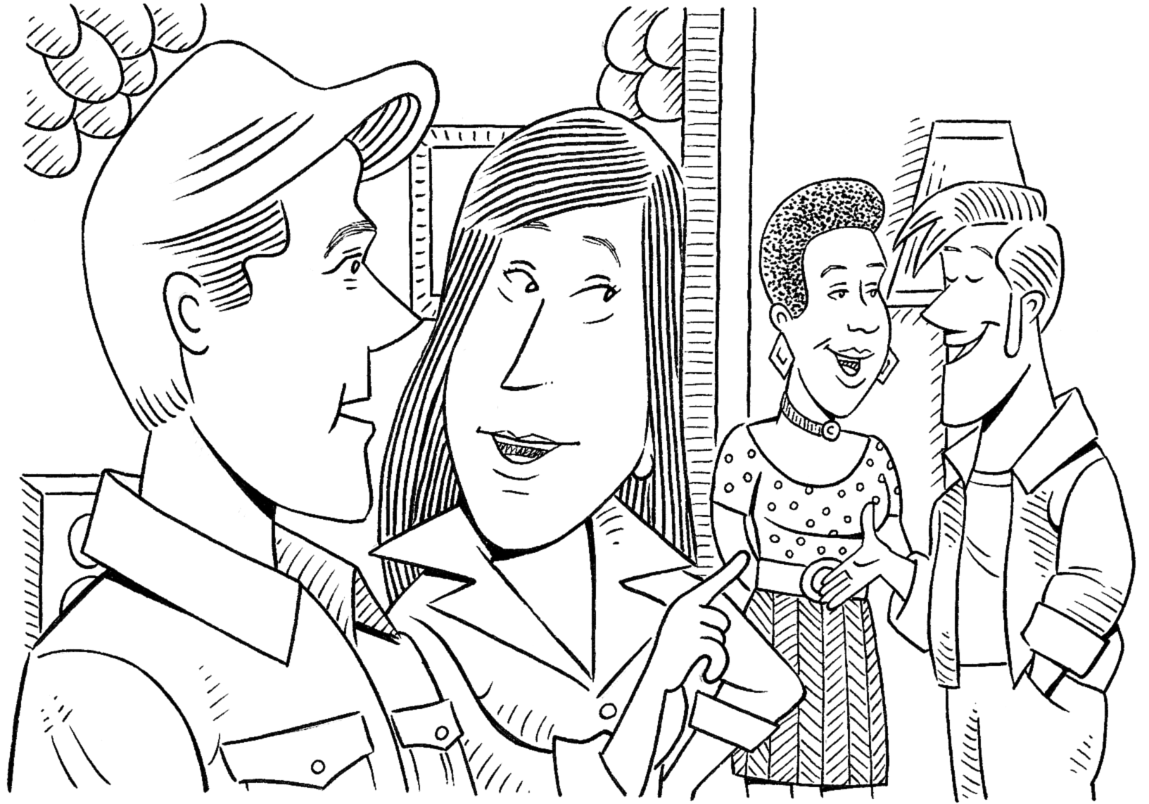
 | Lisa: | Dan Bolton. _________ in my class.
 |  | And _________ name is Samantha Clark.
 | Will: | _________ in your class, too, right?
 | Lisa: | Well, yes. _________ my teacher!
HELLO AND GOOD-BYE
GROUP WORK Complete the conversation. Then act it out.

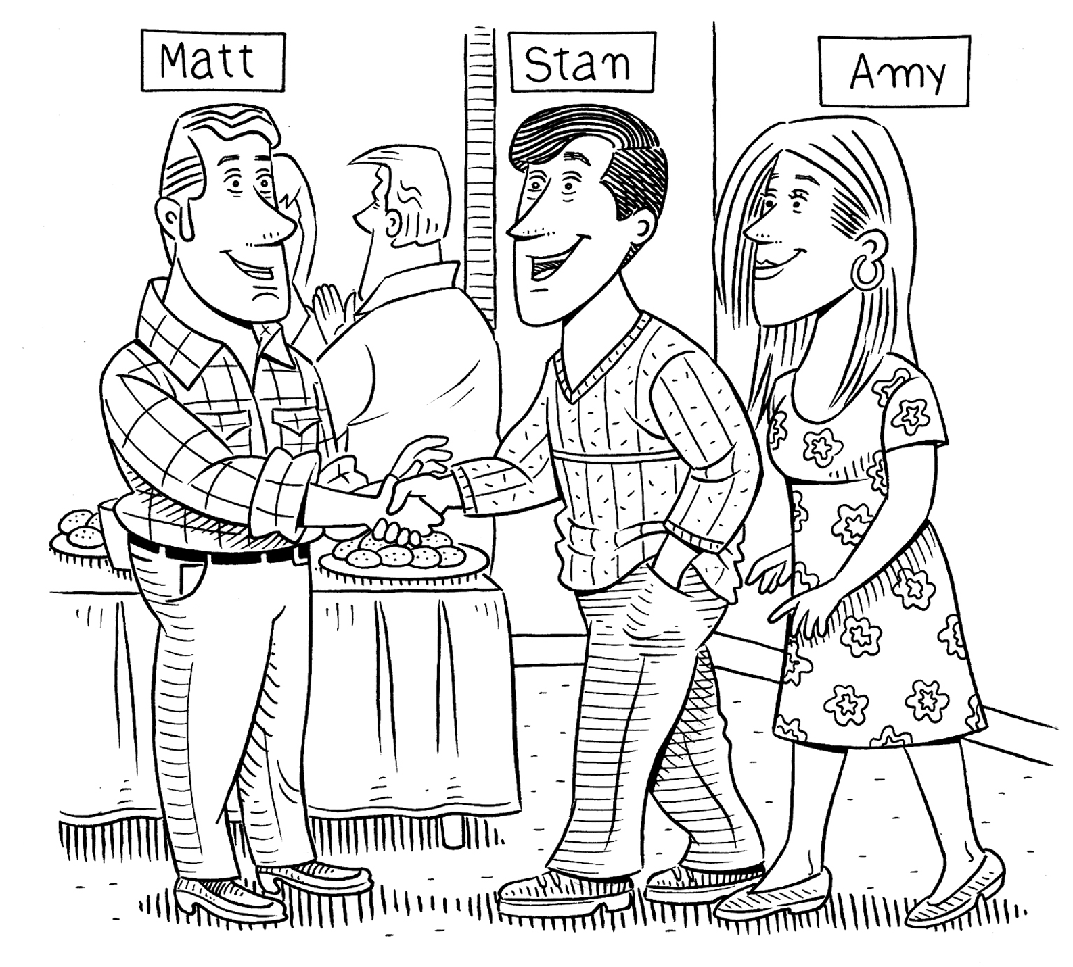 |  | 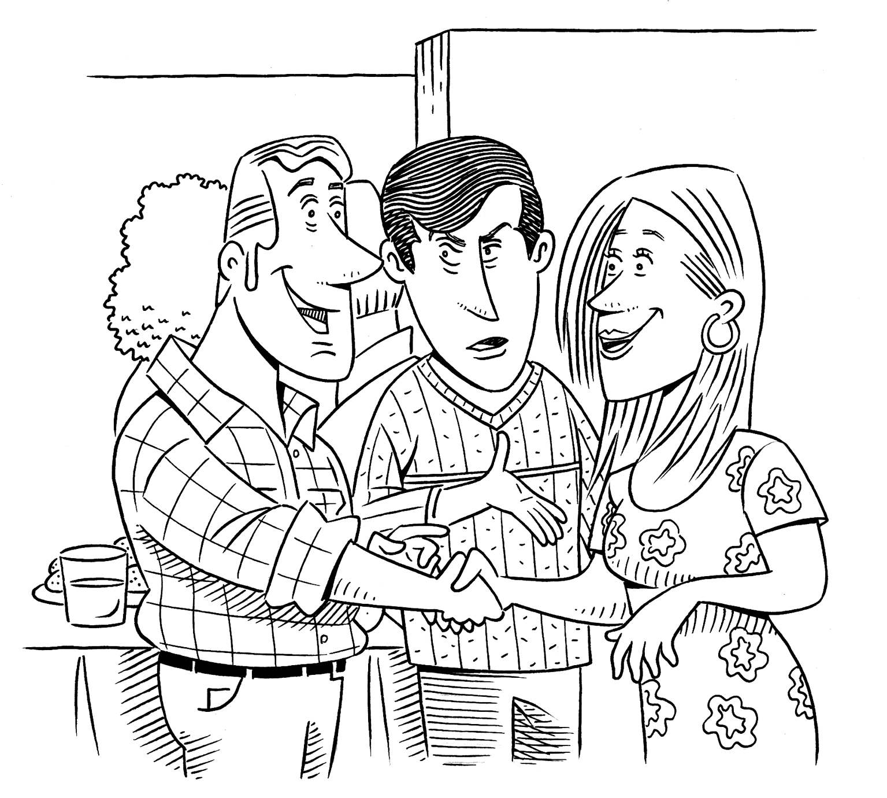 |  | 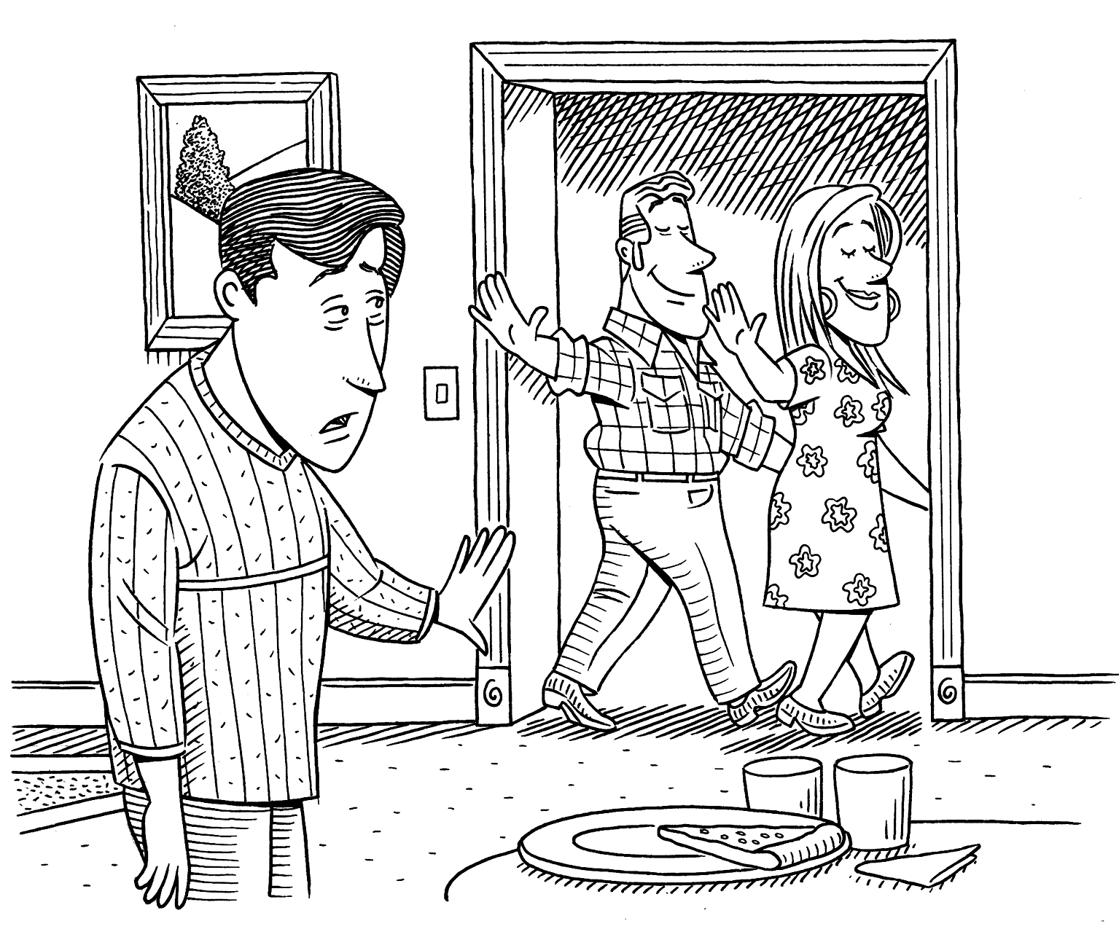  Later . . .

Stan: |  | Stan: |  | Matt: | , Stan!
 |  |  |  | Amy: | Good-bye, Stan!
Matt: | Hello, Stan. | Matt: | Nice to meet you, Amy.
 |  | Amy:

